Introduction to Electronic Commerce
Spring 2008

Professor: | Bing jia Shao | E-Mail: shaobj@126.com
Class Time: | Saturday 1-4 (week 1-11)  Monday, 7-10 (week 12-18) | Class Location: D1443  D1442
Office: | CEBA CQU 758 | Website: www.cnebr.net
Office Phone: | 023-66899805 （PHS）

Textbook and Readings:

Efraim Turban Electronic Commerce: A Managerial Perspective 2006, 4/E

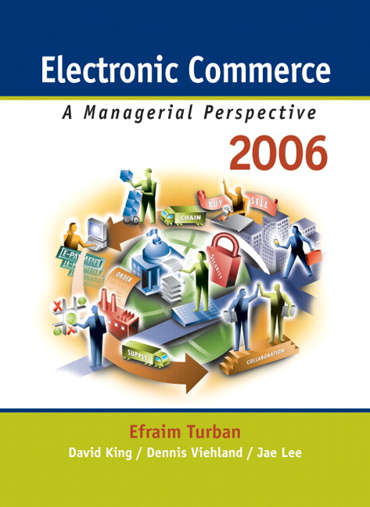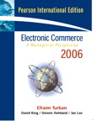

http://vig.prenhall.com/catalog/academic/product/0,1144,0131854615,00.html

http://www.prenhall.com/turban/

http://wps.prenhall.com/bp_turban_ec_2006/0,11174,2580469-,00.html

(Free website resource strongly recommend)
Order Phone#：010-82504008-114 13911301819 RMB:70

2. 《电子商务--管理视角(第3版影印版) 》(美)特伯恩 高等教育出版社 (2006-12出版)
市场价：￥49.00 元
卓越价：￥44.10 元 折扣： 90折 节省：4.90元

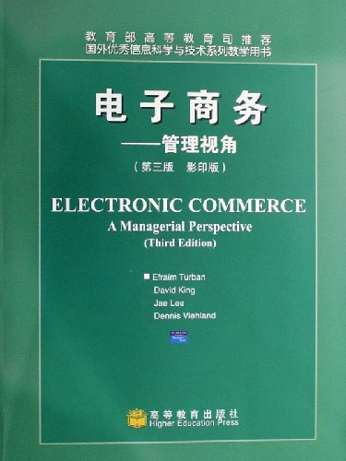

3. (美) 弗雷姆，特班 Efraim Turban;Dave King; Jae Kyu Lee; Dennis 译者:严建援 《电子商务：管理视角》(原书第4版) 机械工业出版社 书号 9787111208976 2007年3月 定价 68：00元 会员价：￥51.00(75折) 师生团购热线电话：13701323720、13701323721
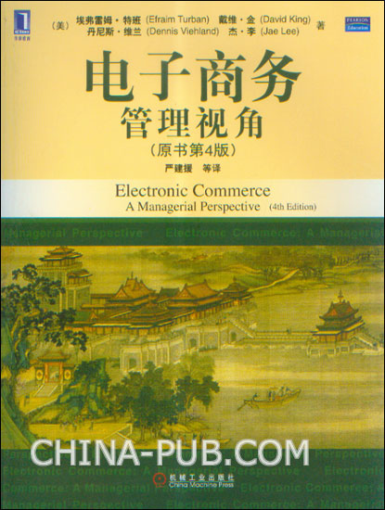

4 邵兵家 《电子商务概论》（第2版）高等教育出版社 2006年6月



Content
Part I Introduction to E-commerce
Ch 1 Concepts and Essentials of Electronic Commerce
Ch 2 E-marketplaces and Economic Impacts
Part II B2C EC-Internet Marketing
Ch 3 Retailing in Electronic Commerce (E-Tailing)
Ch 4 Market Research and Advertisement in Electronic Commerce

Part III B2B and C-commerce
Ch 5 Company-Centric B2B
Ch 6 B2B Exchanges and Services
Ch 7 E-supply Chain, Intrabusiness, Corporate Portals, C-commerce
Part IV Other EC Models and Applications
Ch 8 E-Government, E-learning, C2C, Knowledge Management
Ch 9 Mobile Commerce and Pervasive Computing
Part V EC Support Services
Ch 10 Auctions
Ch 11 E-Commerce Security
Ch 12 Electronic Payment System (B2C, B2B)
Ch 13 Order Fulfillment and Other Support Services

Part VI EC Strategy and Implementation
Ch 14 EC Strategy and Implementation
Ch 15 The Economics of EC
Ch 16 Launching a Successful Internet Business
Ch 17 Legal and Social Impacts and EC Future

Part VII Application Development (Online Only)
Ch 18 Building EC Applications

Course Overview & Objectives:
It is impossible to ignore the importance of electronic commerce in the contemporary managerial environment. Internet facilitated electronic commerce accounts for billions of dollars in transactions, while trillions more regularly pulse through the veins of non-Internet electronic commerce systems. Electronic commerce lies at the forefront of modern marketing and strategic management, altering the competitive landscape for large and small corporations alike. The Internet and new media are reshaping industries, creating new opportunities, and challenging existing commercial models and relationships. Managers will need to understand the underpinnings of electronic commerce in order to make informed decisions about the future their firms and industries. Using a managerial perspective, this course focuses on key issues related to e-commerce including strategy development, competitive advantage, current and emerging technologies, pricing, distribution channels, promotion, and advertising.

Ch 1 Concepts and Essentials of Electronic Commerce
Ch 2 E-marketplaces and Economic Impacts
Ch 3 Retailing in Electronic Commerce (E-Tailing)
Ch 4 Market Research and Advertisement in Electronic Commerce
Ch 6 B2B Exchanges and Services
Ch 11 E-Commerce Security
Ch 12 Electronic Payment System (B2C, B2B)
Ch 13 Order Fulfillment and Other Support Services
Ch 14 EC Strategy and Implementation
Grading:
Exam | 60-70%
Project & Experiment | 30-40%
TOTAL | 100%

